**IT24104076**

**Jayasinha W.M.S.S.N**

**Probability and Statistics**

**Lab Sheet 09**

1. i)

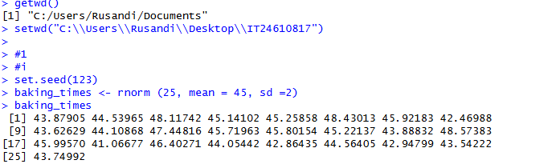

ii)

